**AN INDUSTRIAL TRAINING REPORT**

At

# DESIGN INNOVATION CENTRE, UIET



Date: from June to July, 2022

*SUBMITTED IN PARTIAL FULFILMENT OF THE REQUIREMENT FOR THE AWARD OF THE DEGREE OF*

**BACHELOR OF ENGINEERING**

**(INFORMATION TECHNOLOGY)**



**Submitted By:**

Arham Jain (UE208022)

Semester 5

To

Department of Information Technology

University Institute of Engineering and Technology

Panjab University, Chandigarh

October, 2022

**Table of Contents**

|  |  |  |
| --- | --- | --- |
| **S.No** | **Content** | **Page No.** |
|  | Certificate | 3 |
|  | Declaration | 4 |
|  | Acknowledgement | 5 |
| Chapter 1 | 1. Introduction   * 1. Introduction to the industry/Organization   2. Introduction to Project   2.3 Scope of the Project | 6-10 |
| Chapter 2 | The Technology used (Hardware & Software) | 10 |
| Chapter 3 | Project Details including Snapshots and results/outcome | 11-15 |
| Chapter 4 | Conclusion | 16 |
| Chapter 5 | Future Scope | 17 |
|  | Bibliography | 17 |

**CERTIFICATE OF MENTORING:**



# DECLARATION

I hereby declare that I have completed 30 days of summer training program from 7th July,2022 to 5th August,2022 under guidance of Dr. Prashant Jindal and Dr. Mamta Juneja**.** I declare that I have worked with full dedication during these 30 days of training and my learning outcomes fulfill the requirements of training for the evaluation of Full Stack Web Developer.

Arham Jain

BE IT 5th Sem

UE208022

**Acknowledgement:**

I extend my heartfelt gratitude to the management of Design and Innovation Centre (Medical Devices & Restorative Technologies) for granting me the valuable opportunity to train and learn “WEB-DEVELOPMENT” at one of their top-class research laboratory. In particular, my appreciation goes to Principle Investigators Dr. Prashant Jindal and Dr. Mamta Juneja for approving and admitting me and my training in-charge Vishal Kumar Singh (PROJECT LEAD OF WEB-DEVELOPMENT) for his precious guidance and support rendered to me throughout the training.

I also thank all the fellow staff and student members especially those of the Web Technologies Domain for the great ideas and thoughts shared with me during the entire training period and for their hospitality and cooperation that made it inevitable for me to acquire the much-desired practical knowledge and skills in the field of Information Technology. Special thanks also go to the Information Technology Engineering Department of UIET, PANJAB UNIVERSITY and the University Administration at large for availing me with this study time so as to apply the theoretical skills learnt in class into real life problem-solving situations and understanding of the IT industry profession at large.

Arham Jain

BE IT 5th Sem

UE208022

**Chapter-1**

**INTRODUCTION:**

1.1 Introduction to Industry:

The web industry is one of the most profitable business in the modern world. The industry that is known for its web development has created a world where information is abundance and available for anyone, anywhere and anytime.

Beside being one of the youngest and the most profitable, web development has been one of the fastest growing industries in the world since the mid-1990s. In 1995 there were fewer than 1,000 web development companies in the United States, but by 2005 there were a massive increase to over 30,000 of such companies in the U.S. alone.

WEB DEV INDUSTRY STATS:

* 48% of people credit a website’s design as the top factor in deciding a business’s credibility.
* 73% of companies are investing in web design to differentiate their brands
* the web design services market size in the us is 40.8 billion
* 68% of consumers say they have higher expectations for businesses’ digital capabilities since covid-19.
* websites that load slowly lead to a $2.6 billion loss in revenue every year
* 62% of companies increased their sales by designing responsive mobile platforms for their websites.
* 40% of users will leave non-responsive websites
* over 380 new websites are created every minute 88% of online customers will not return to a website following a bad experience
* 94% of people say bad design is the main reason they don’t trust certain websites.
* 8 of 10 consumers would stop engaging with content that doesn’t display well on their device.

Chapter-1.1

Introduction to Project:

E-COMMERCE APPLICATION

Electronic Commerce is exactly analogous to a marketplace on the Internet. Electronic Commerce (also referred to as EC, e-commerce eCommerce or ecommerce) consists primarily of the distributing, buying, selling, marketing and servicing of products or services over electronic systems such as the Internet and other computer networks.

THE ELEMENTS OF E-COMMERCE

In the case of E-commerce, all the above-listed elements are available but they are having slight variations in the real-life situation.

* A Product or Service: In the case of E-commerce, it is a virtual product shown on a website. One can demonstrate a multimedia presentation of the product & its entire feature on the web page itself, which may not be possible in the case of physical product of commerce activity.
* A Place to sell the Product: In the e-commerce case, a website displays the products in all ways & acts as a place for E-Commerce.
* A way to get Customers to visit your Website: In the case of E-Commerce search engines and linkages with other websites play an important role in helping the customers to reach web sites of the organizations.
* A way to Accept Orders: The orders are accepted on the website Itself. On the web pages of the E-commerce companies shopping carts are being provided. One can click on the lean and fill in the shopping I card to order items to be purchased and it is accepted by the E-commerce Company as an order from the customer.
* A way to Accept Money: In the case of traditional commerce, buyers and sellers are in direct contact with each other.

1. Models of E-commerce
   * Business-to-consumer transactions
   * Business-to-business transactions
   * Consumer-to-consumer transactions

**Chapter-1.2**

**COMPONENTS/ MODULE EXPLANATION:**

I am using Full Stack Java-script to design and develop my Website . In this I used Node, Express and MongoDB to design the REST APIs and then I used APIs in my React frontend.

So, basically it would be a simple E-Commerce website. It would not have all the bells and whistles of a complete modern E-Commerce website since this is aimed at learning and understanding how everything actually works. But I can surely add features on top of this project to make it better. I keep my design simple and minimal on Frontend side. I may not be dealing with CSS much as my focus would be on understanding how to deal with APIs on the frontend and will focus on the basics part.

I used React Bootstrap to design our React Frontend minimally. My aim is to make a working e-commerce website where everything functions correctly.

So, the features we would be having in the application that we would be building are:● Authentication using JSON Web Tokens (JWT).

* Option to add, edit, view and delete all the items in our store.
* Option to add items or remove items from the cart.
* Display the total bill of the cart and update it as soon as the cart is updated by the user.
* Using Local Storage to store the JWT so that we only allow logged-in users to buy items.
* Option to pay and checkout thus creating order and emptying the cart.

So, these are the basic features I would be having in our application. Now, let’s get familiar with the tech stack I used for building this application.

**Chapter-1.3**

**Scope of Project:**

The project can make use of various new technologies and features to help ease the overall E-shopping experience of customers. We can improve these E-Commerce Applications using the above mentioned points.

The scope of e-business in the near future looks to be ever-increasing and growing, because the trend has really caught on here. E-commerce giant Amazon is keen to conquer the Indian market and has already invested a great deal, especially with its 49% stake in the Future Group.

Indian online retail giant Flipkart has already opened a few offline stores and plans more stores in smaller cities. They plan to combine online and offline stores to maximize their selling potential.

The Government of India is also making a huge push for Ecommerce by providing numerous sops to start-ups, cyber parks, and so on through its Digital India program.

As of now, there are close to 20,000 E-commerce companies in India, with many more expected to join the bandwagon every month. Experts are of the opinion that by 2034, we will outperform the US where online shopping is concerned, becoming the second-largest e-commerce economy in the world.

**Chapter-2**

**TECHNOLOGY USED:**

1. MERN

MERN stands for MongoDB, Express, React, Node. With these technologies that make up the stack.

* + MongoDB - document database
  + Express(.js) - Node.js web framework
  + React(.js) - a client-side JavaScript framework
  + Node(.js) – NODE.js is a JavaScript-based web server

1. Advantages of MERN Stack
   * UI Rendering and Performance
   * Cost-Effective
   * Open Source
   * Easy to Switch Between Client and Server

MERN Stack is a collection of powerful technologies and robust, used to develop scalable master web applications comprising backend, front-end, and database components. It is JavaScript that is used for the faster and easier development of full-stack web applications. MERN Stack is a technology that is a user-friendly full-stack JavaScript framework for building applications and dynamic websites.

MERN Stack consists of four main components or can say four main technologies:

* + M stands for MongoDB ( Database ), mainly used for preparing document database and is a NoSQL (Non-Structured Query Language ) Database System
  + E stands for Express, mainly used for developing Node.js web framework
  + R stands for React, mainly used for developing a client-side JavaScript framework
  + N stands for js, mainly used for developing the premier JavaScript web server Each of these four technologies plays an important role in providing an end-to-end framework for the developers. Even these four technologies play an important role in the development process of web applications.

**Chapter-3 Project Snapshots:**

Starting Page:

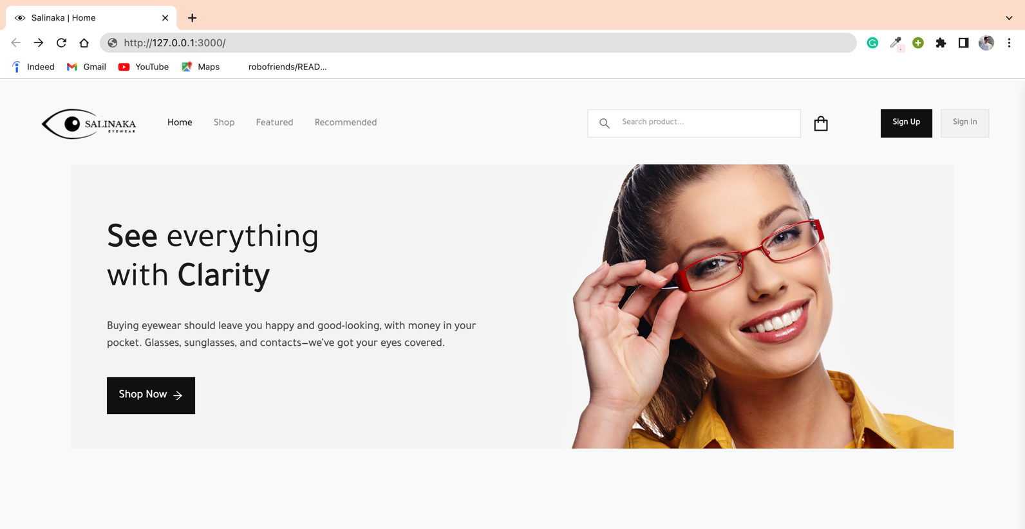

Featured Products:

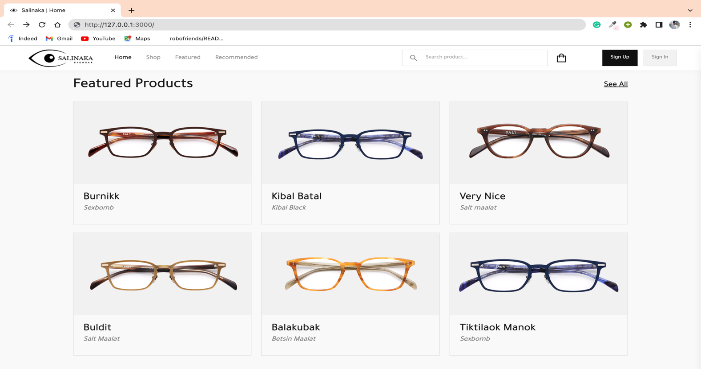

Recommended Products Page:

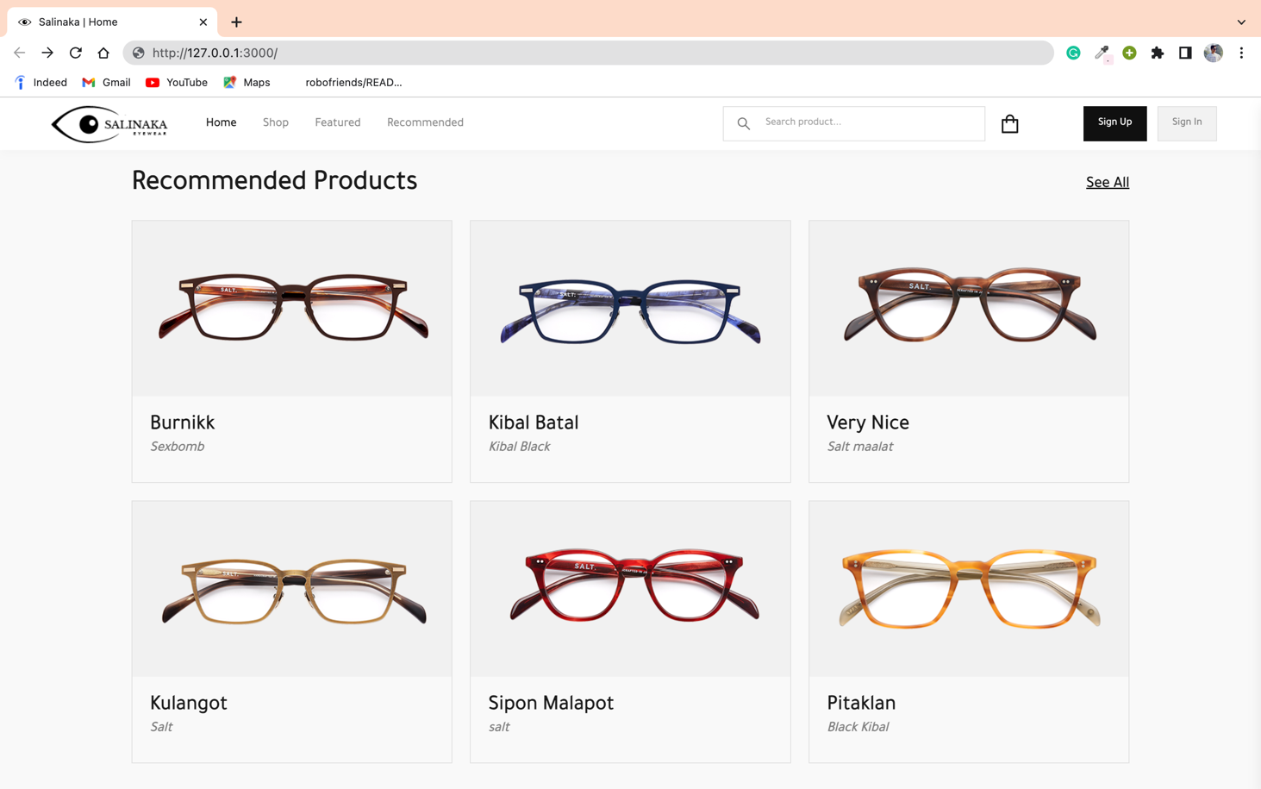

Footer-Page:

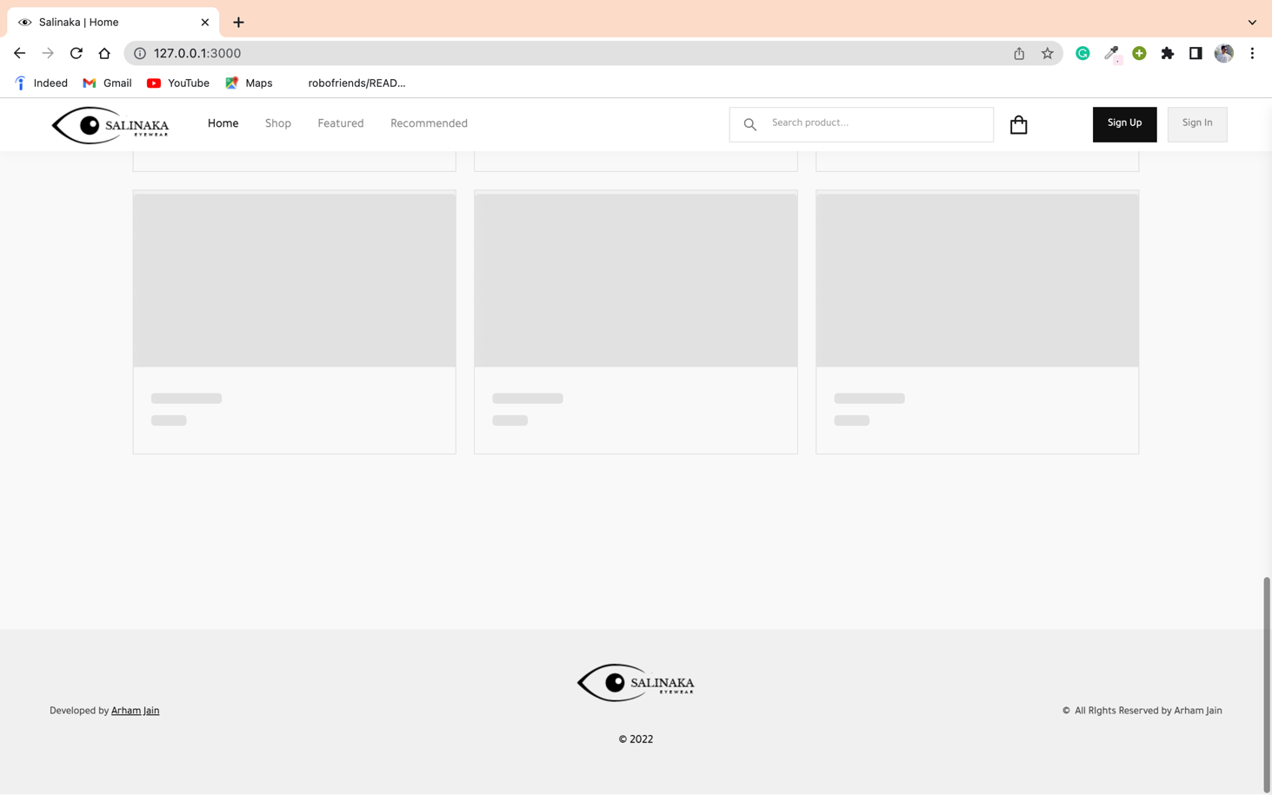

Product-Image Page:

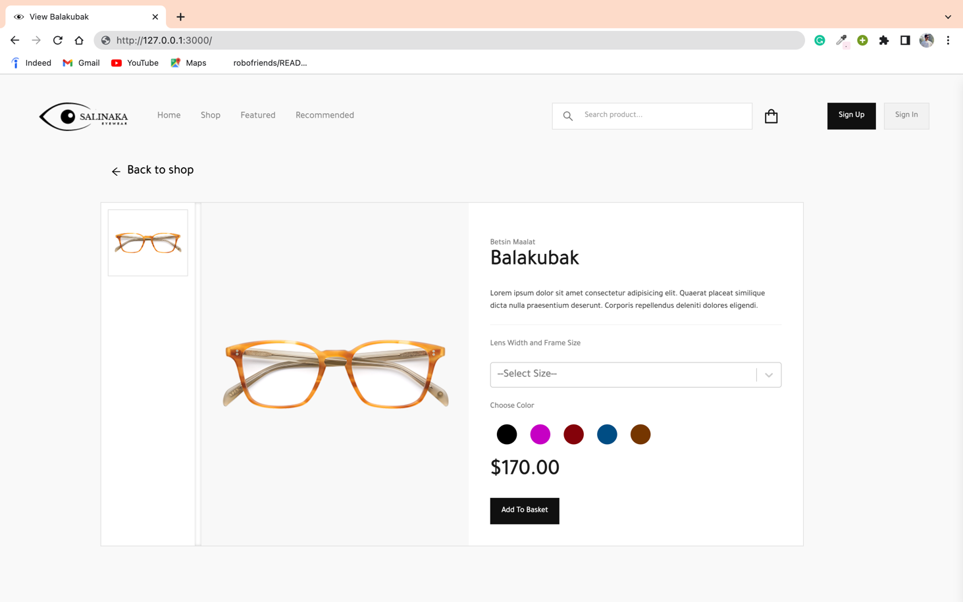

Items-Cart Page:

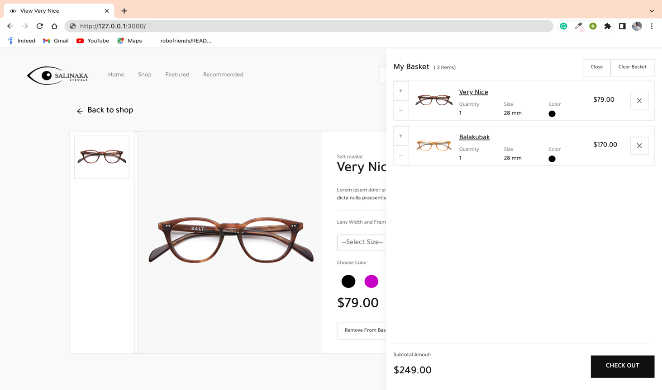

Checkout-Page:

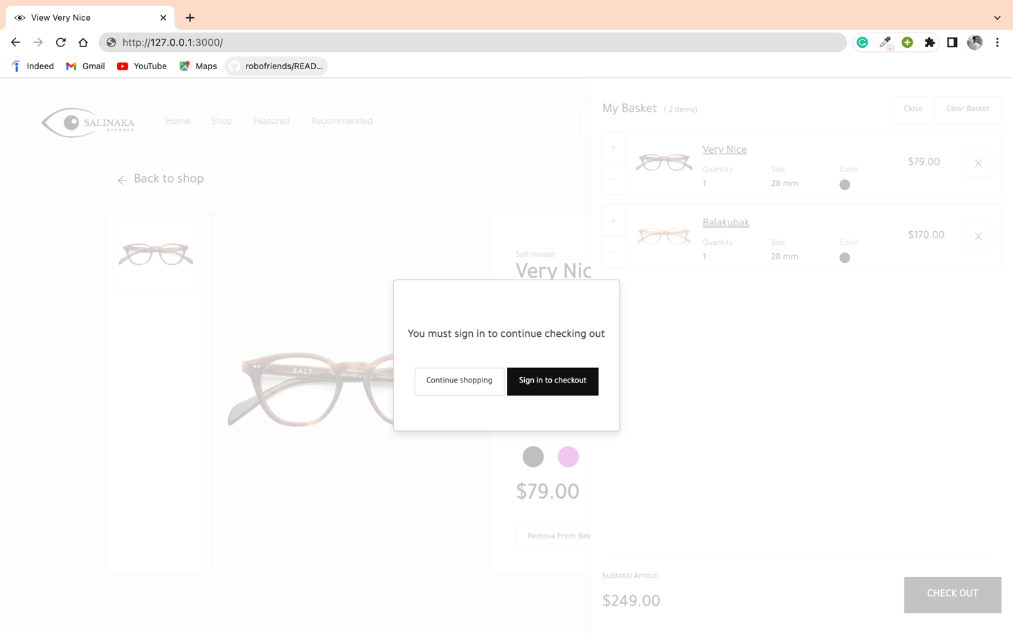

Sign-Up Page:

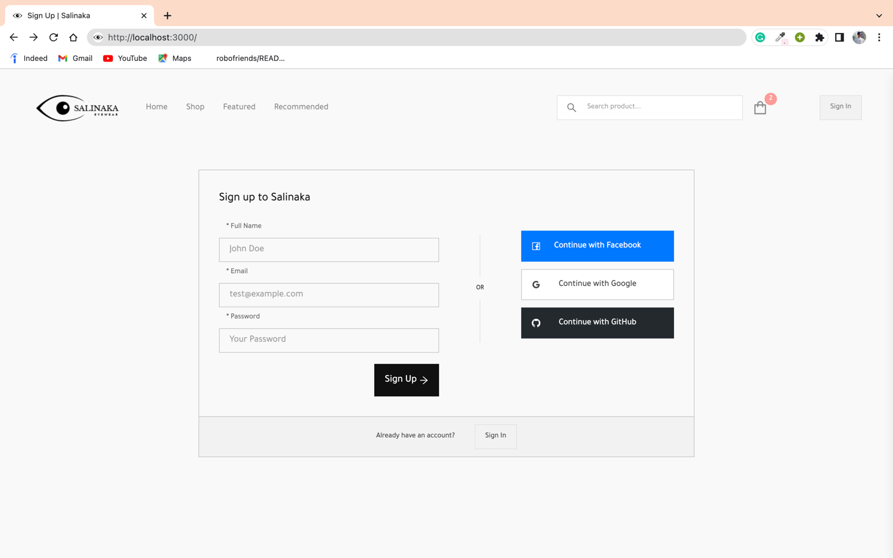

Sign-In Page:

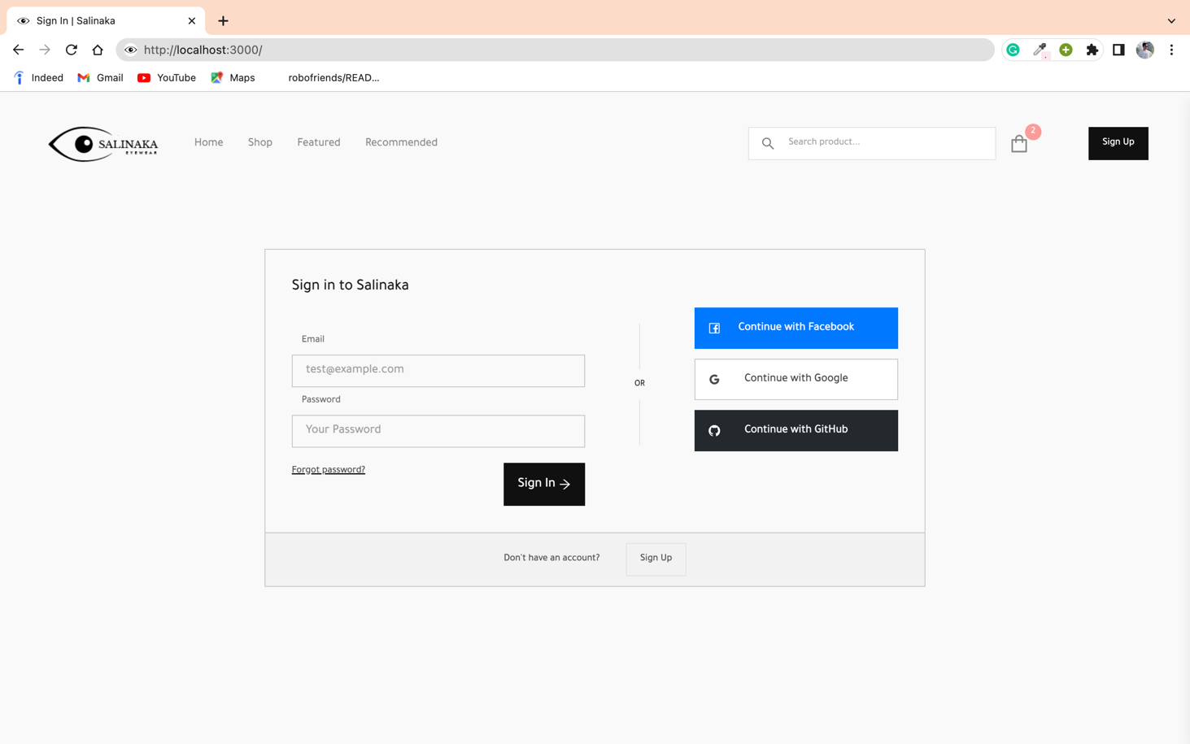

**Chapter-4**

**CONCLUSION:**

The conclusion of this whole summer industrial training of one month is that, throughout the whole training I came across the different technologies under the “MERN” stack used in modern day WEB-DEVELOPMENT domain.

I get to know the insights about the each and every process right from designing the architect of the website to the creation of front-end and backend to the final integration and hosting of the website.

Along with this being an IT undergrad I got in-depth knowledge about the operations and functions of software development in a team. By studying and observing the functionality of the REACT.js library, NODE.js, EXPRESS.js .

**Chapter-5**

**FUTURE SCOPE:**

The future scope of learning the latest web-dev technologies and tech stacks like MERN is that this can prove a canon in the career of a software developer as it leads to doors to the Technologies like:

* Artificial Intelligence
* Virtual Reality
* Voice Functionality
* Internet of Things (IoT)

A web developer can find himself/herself working for the following roles with an average pay of $10000/annum (IND) and $42000/annum (US-EUR)

* Web App Developer
* UI Designer
* Front-end or Backend Developer
* UX Architect
* UX Designer
* Web Marketing Analyst

**BIBLIOGRAPHY:**

Resources referred:

* Learn to Code — For Free — Coding Courses for Busy People (freecodecamp.org)
* Learn to code online – CodeWithHarry
* React – A JavaScript library for building user interfaces (reactjs.org)
* Node.js (nodejs.org)
* MongoDB Atlas: Cloud Document Database | MongoDB
* Express - Node.js web application framework (expressjs.com)